Independent Study
Support and Guidance

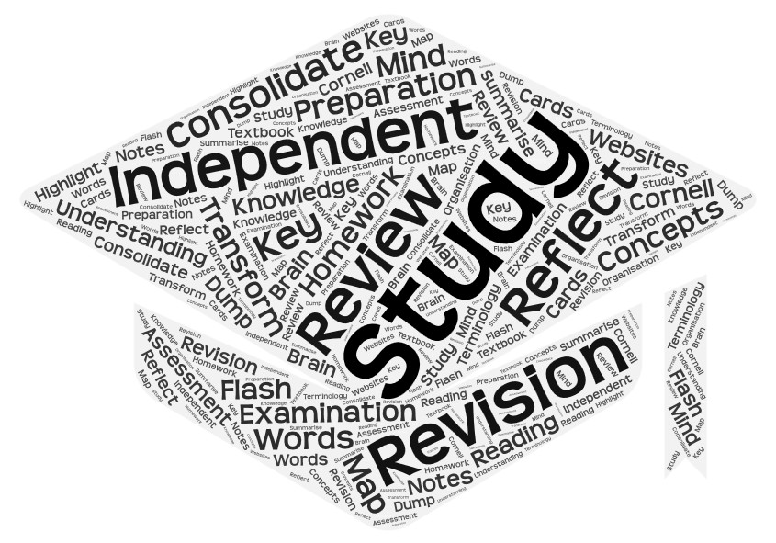

Student Booklet

Introduction

Independent study is NOT revision!

Let’s start of by making this absolutely clear; independent study takes place whilst you are still learning the content of your course. You will be revising alongside this but independent study is about helping you get to grips with and learn the content of your courses. It is also not homework/prep. Homework/prep are specific tasks that your teacher has asked you to complete ready for a lesson or to be taken in for marking.

To successfully and effectively study for your A Levels you need to go beyond simply reading your textbook or looking up information on the internet. To truly be able to understand the content you need to be doing something with the information, showing that you have learnt and can use the information not just regurgitated it.

At A Level it is suggested that for every hour of classroom based work you do you should be doing an hour of self study and homework. This way you will build up the independent learning skills necessary for success not only at A Level but also at University level and in the world of work.

What this booklet aims to do is give you the strategies and activities necessary to help your do this. It contains a number of activities which will help you not only prepare for your lessons but also to reflect and consolidate on what you have learnt in your lessons and practice exam technique. It is not an exhaustive or exclusive set of activities, and it is likely you will need to adapt some of them to meet the requirements of your different courses and examination requirements.

Time Management

There is a big jump from GCSE to A Level, and one of the biggest challenges you will face is the increase in how much independent work you are expected to do on top of your homework, and also unlike GCSE where your teacher will tell you what you need to be doing to prepare for your lessons and study for the course, at A Level you are expected to do this yourself. This expectation of independence can become quite overwhelming, so it is important that you know how to prioritise your workload and manage your non-contact time effectively.

One of the big differences between 6th form and main school is that you now have non- contact periods during the school day. In order to use your time effectively it is important
that you see these times as study opportunities and not free time to relax with your friends. By
using the time effectively during the day it means that your time out of school can be much more flexible and open.

Strategies

1. Separate your study from homework.
By separating your homework time from your study time your will be able to manage all the tasks that you need to do. Whether you decide to use your non-contact time to complete the homework set by your teachers or for studying it doesn’t need to be fixed. Depending on the day you have, the
amount of homework that has been set and your own wellbeing can determine how you use your non contact time.

2. Plan what you are going to do and be specific
It is not enough to just say you are going to study or that you are going to do homework, you do need to give your self set tasks to complete. It is much easier to stay focused on a specific task then it is on a vague intention to study
or complete homework. Each task should take around 30 minutes to complete, that way you will not over estimate what can be achieved in the time that you have. Being specific in your planning also has a psychological element in that having tasks to complete on a to do list, it is easier to see you are making
progress and therefore you are more likely to keep going.

When planning you should only plan 2 days in advance as you can never know what will come up and this can then lower stress levels if you are unable to complete everything.

3. 10 minute rule
When you start whatever task it is that you have planned to do, you should persevere with that task for at least 10 minutes before you decide its just not going to happen. Sometimes you can find that by persevering for 10 minutes you get into the zone and are able to continue, but if after that 10 minutes you find that its not going in or that your brain is just not in the right frame, then take a break and try a different task.
However, it is important that you recognise the difference between not
WANTING to do a task and not being in the right frame of mind.

Planning your time and tasks

There are a lot of ways to plan your non-contact time and evening/weekend work. Below are a few of them that you can try work out what works best for you.

1. Weekly Planner
A weekly planner in which you set yourself tasks for the day linked to each of your subjects. This system gets you to simply set yourself 2 or 3 tasks that you want to achieve in that day. It doesn’t set when you are going to do it so it this system is best suited for school holidays and evenings rather than for non-
contact time during the school day. You can buy weekly planners in most shops which sell stationary these days and they can be easily adapted. Alternatively you can download this weekly planner using the QR code.

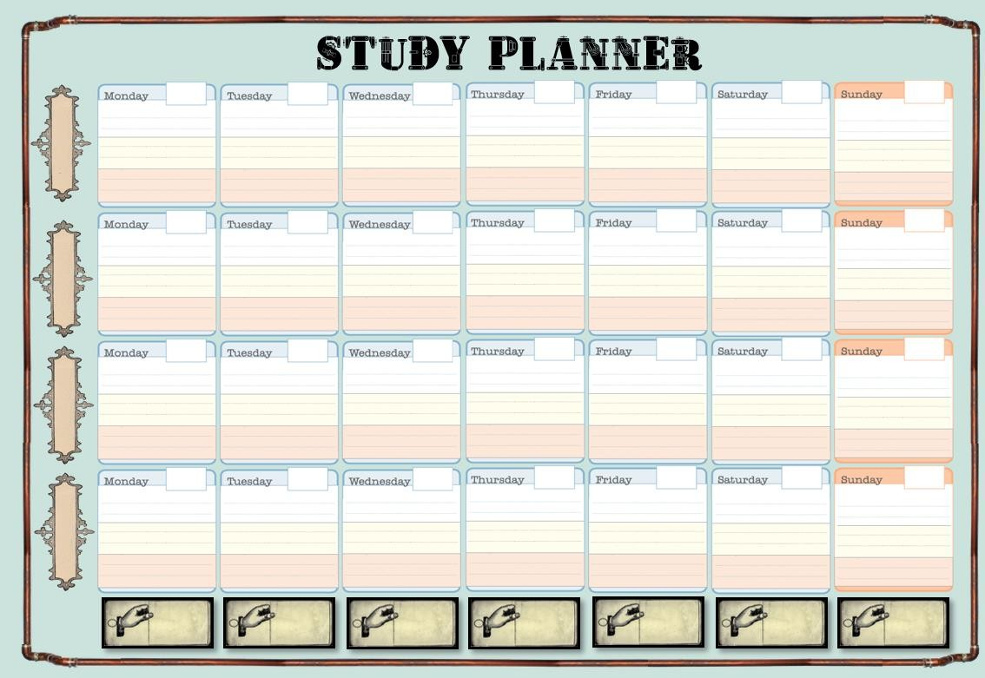

2. Daily planner
A daily planner can help you to determine how you are going to spend your non contact periods as well as record any homework that you are receiving. It is very similar to a homework diary that you may have had in main school or a teacher’s planner, which identifies exactly what you are doing over the course of that day when you are not in lessons. Again many variations of these can be brought online or you can create your own in a notebook or adapt an
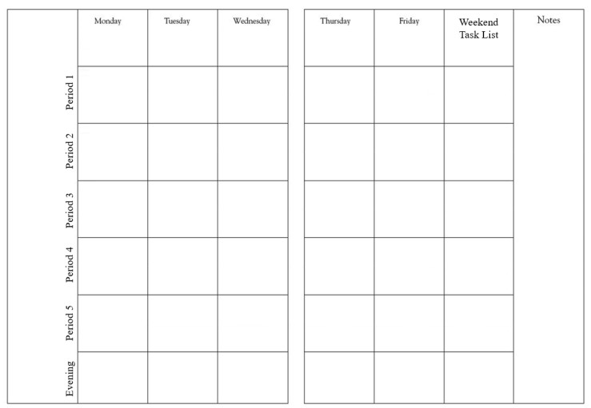academic diary.

Here is an example of how you could plan your time – remember only plan 2 days at a time to give you the flexibility should life happen.

A 1 2 3 4 5 Evening Tasks

Read through last weeks History notes
Monday

HISTORY
HWK Due – Essay

Read through last weeks BS notes

PSYCH BUSINESS STUDIES

Psych: HSW Lorenz
study – Thurs
plan HWK Set: HSW
Lorenz study – due
BS: Exam Q’s – Weds
History – Course
Read through last
weeks Psych notes

Trigger sheet on causes of French revolution.
Tuesday

Quiz on Macro
Economics
Wednesday
20 marks of BS
questions

HISTORY HISTORY
Thursday

Plan 16 marker for Abnormality

Read up on macro econ misconceptions

PSYCH
work intro

History – Course work finish intro

Psych – 16 marker on abnormality.

BUSINESS STUDIES

FUTURES HISTORY

HWK Due – Exam
Q’s

PSYCH PSYCH HISTORY BUSINESS
Thursday

HWK Due – HSW Lorenz
STUDIES

BUSINESS STUDIES
Weekend Tasks
Friday
BUSINESS STUDIES
PSYCH

HWK Due – 16
mark Q

Your can see from this example that the tasks have been colour coded: Red – Study
Black – Homework set or due
Blue – Homework tasks to complete.

I have also only looked at Monday and Tuesday but have added in when homework is due in so that I don’t forget to bring it to the lesson. I have also completed it at least 2 days before the due dates to ensure that if I hit a problem or something I don’t understand I have time to speak to the teacher or get help.

Study Management

Studying can seem like an extremely big task to get to grips with. The A Level course have a lot of content to cover over 2 years and trying to remember content from the start of year 12 in year 13 can seem impossible. This is why it is so important to prioritise your study and remember that you don’t need to be studying everything all the time, but with realistic prioritisation and reflection it is completely manageable.

There are many ways to prioritise your study but some of the most effective are ones which allow you to see the progress you are making and then really focus on the areas of difficulty rather than looking at the whole syllabus in one go.

Prioritisation Matrices

A prioritisation matrix is an very effective method to prioritise and focus your study. It is a very simple premise that requires an A3 piece of paper and postit notes. The way it works is that on individual postit notes (sticky tabs work just as well) you write down each of the sub topics in your course, this could be colour coded so that you can see if there is a specific unit you need to focus on. You then place the tabs on the matrix (below) in the box which matches your level of confidence in that sub topic. There is also a section for the topics you have not covered yet.

I need to seek help with this. I get it but I am not confident I
could answer a question.
Have not covered this yet

I am exam ready on this. I could answer a question but not get full marks.

This system allows you to reflect at different times through out the course and move items around both towards “exam ready” as well as backwards, when you get feedback from an assessment or quiz. Again it is a way of showing progress as well, showing you that you are moving forward in your study which can be helpful in keeping you motivated.

How To Study

As I am sure you are aware there are lots of study methods and systems around and you may find these helpful, however the system that I am suggesting is a structured study system that you can use throughout your A Level study but still gives you the flexibility to choose activities and strategies that work for you.

At A Level the sheer amount of content that will be covered over the two years means that you cannot wait until the taught elements have been completed before you start to study. Study is something that you should be doing from the get go. This will alleviate some of the stress and anxiety that you might feel when being assessed or as you head into the exam period, as you know you are prepared and you have done all you can. Cramming just before the exam is not an advisable, this system will lead to undue stress and overload.

Spaced Study System

The Spaced System is designed so that each stage of the process happens over a period or time and not in one sitting. Each of the stages (except your lesson) should take around 30 -
45 minutes to complete and does not include any homework that your teacher may set you. This is so that your brain doesn’t become overloaded meaning that nothing is going in and also allows your brain time to process the information and move it from short term memory to long term memory.

Using this system you will be constantly revising content and exam technique so there will not
be a need to cram at the end of the course or as a an assessment approaches; but this is not a silver bullet, it does take commitment from you to work. It will not do it for you!

Part of the process is planning your time effectively in order to make sure that you have a balance between your subjects and your relaxation time. By using a weekly planner and planning 2 days in advance it gives you the flexibility to adjust as new events and tasks come up as well as having off days, but planning is important as it will ensure you are more likely to keep on top of your work load and therefore be able to manage your stress levels. But do remember to build in time to do things for yourself and your wellbeing.

The biggest thing to remember when it comes to studying is that no one can do it for you, it takes time, dedication and it takes perseverance. Your teachers will be there to help you but at the end of the day you are the one who is sitting the exam not them.
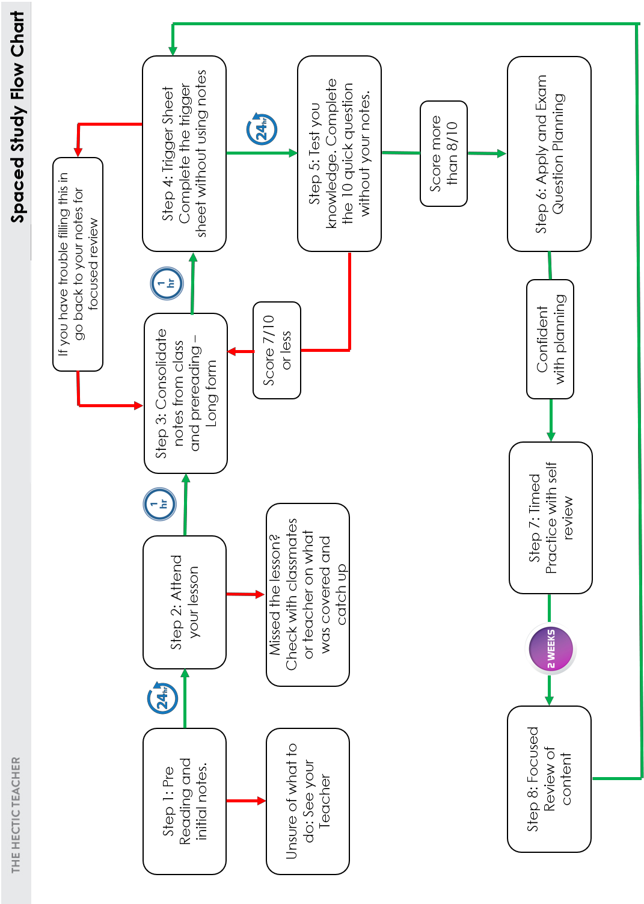

www. hecticteachersite.wordpress.com 7 @hecticteacher

Pre-Reading and Lesson Preparation

The first stage of self study is pre-reading and lesson preparation. This doesn’t mean that you are teaching your self the content of that lesson meaning you don’t need to go to that lesson, it is about giving yourself an idea of what will be covered so that you are not going in cold and going back over prior content to remind your elf of what has previously been taught and how it fits into what you are currently studying.

By reading up before your lesson and looking over the content you will be exposed to any new terminology that might come up as well as concepts, theories and ideas meaning that you are at least aware and ready for the explanation.

This stage however should not consist of simply reading, this is a very ineffective way of studying and merely gives the impression of studying. Additionally highlighting long passages of text is just as unhelpful. This stage is about being focused and targeted so that you are able to add to it during and after your lesson(s).

Some activities you can do for pre-reading preparation include:

• Targeted Highlighting and focused note taking

• Cornell notes

• Key word Quadrants

Each of these activities are explained on the following pages and have QR codes to link to any worksheets/resources.

Targeted Highlighting

Although Highlighting great swaths of text is not an effective method if studying. That doesn’t mean that highlighting doesn’t have its place.
In order for highlighting to be effective it needs to be targeted and purposeful, one way to

do this is by annotating why you have highlighted a particular passage and using this along

side another note taking system.

The importance of representative samples

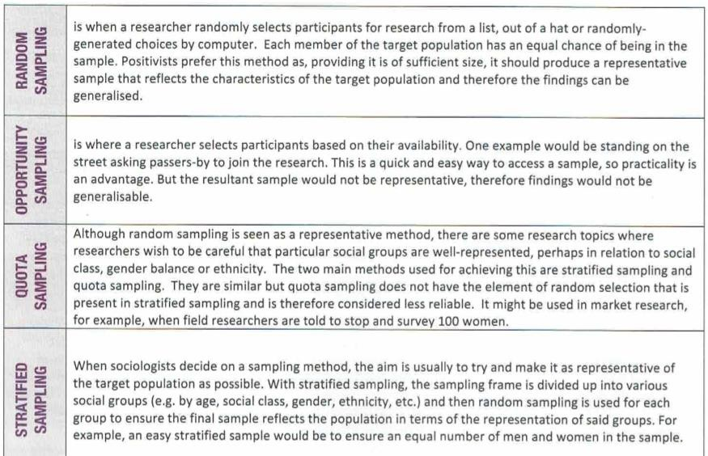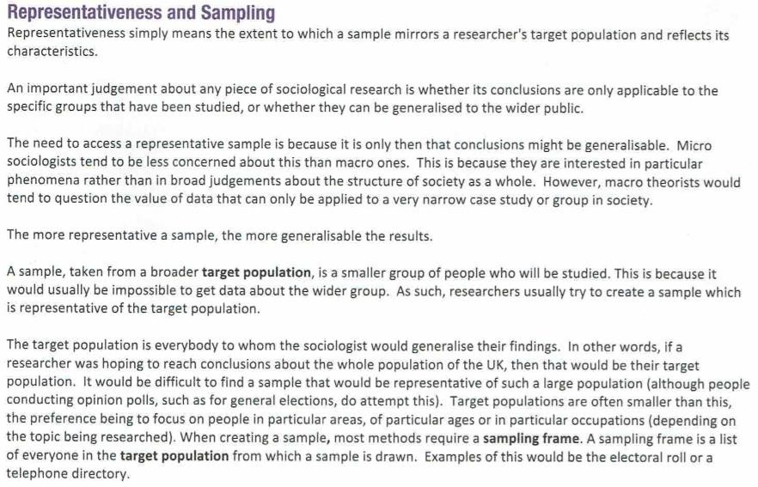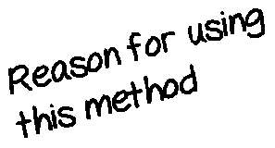Example

Focused Reading

Focused reading is a worksheet that structures the notes that you are taking from the reading you are doing and identifying any areas that you want to make sure you are clear on after
the lesson.

Which exam paper

Specific part of the
specification

Title of the notes you are making

Names of thinkers / Theorists
or people who are associate d with this area

Bullet points of information that are significant to this topic.
Subject specific terminology associated with this topic

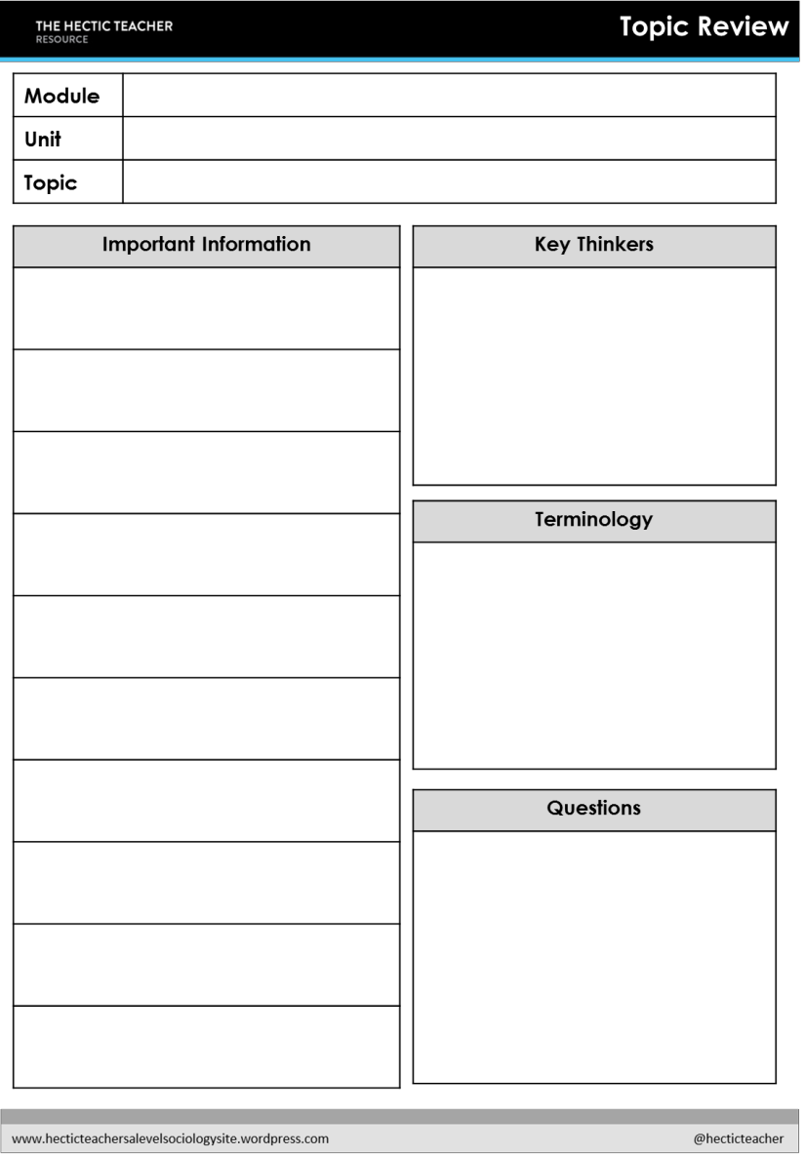Areas that you are unsure on that you need clarification on

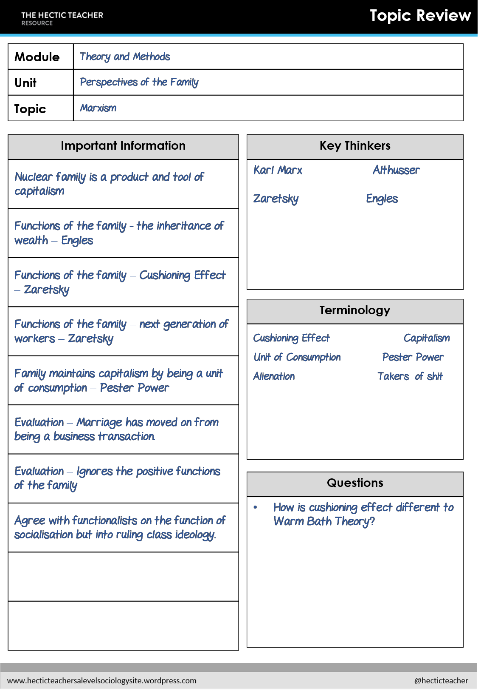Worked Example

www. hecticteachersite.wordpress.com 11 @hecticteacher

Cornell Notes

Cornell notes sheets are very similar to the topic reviews but give a more structured approach which organises your notes for you according to the assessment objectives in your course. The idea is that you take bullet point notes in the main section and then later using those points to create a short summary of the content of this topic.
There is also space for your to write questions you might have so that you can cross them off

when your teacher answers them in class.

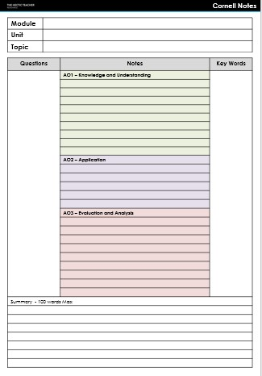Which exam
paper

Specific part of the specification

Title of the notes you are making

Areas that you are unsure on that you need clarification on

Knowledge - these are the facts that you need to know
Subject specific terminology associated with this topic

Application - examples to illustrate the knowledge.

Evaluation – Criticisms and supporting evidence.

Summary – bringing everything together into a single paragraph.

www. hecticteachersite.wordpress.com 12 @hecticteacher

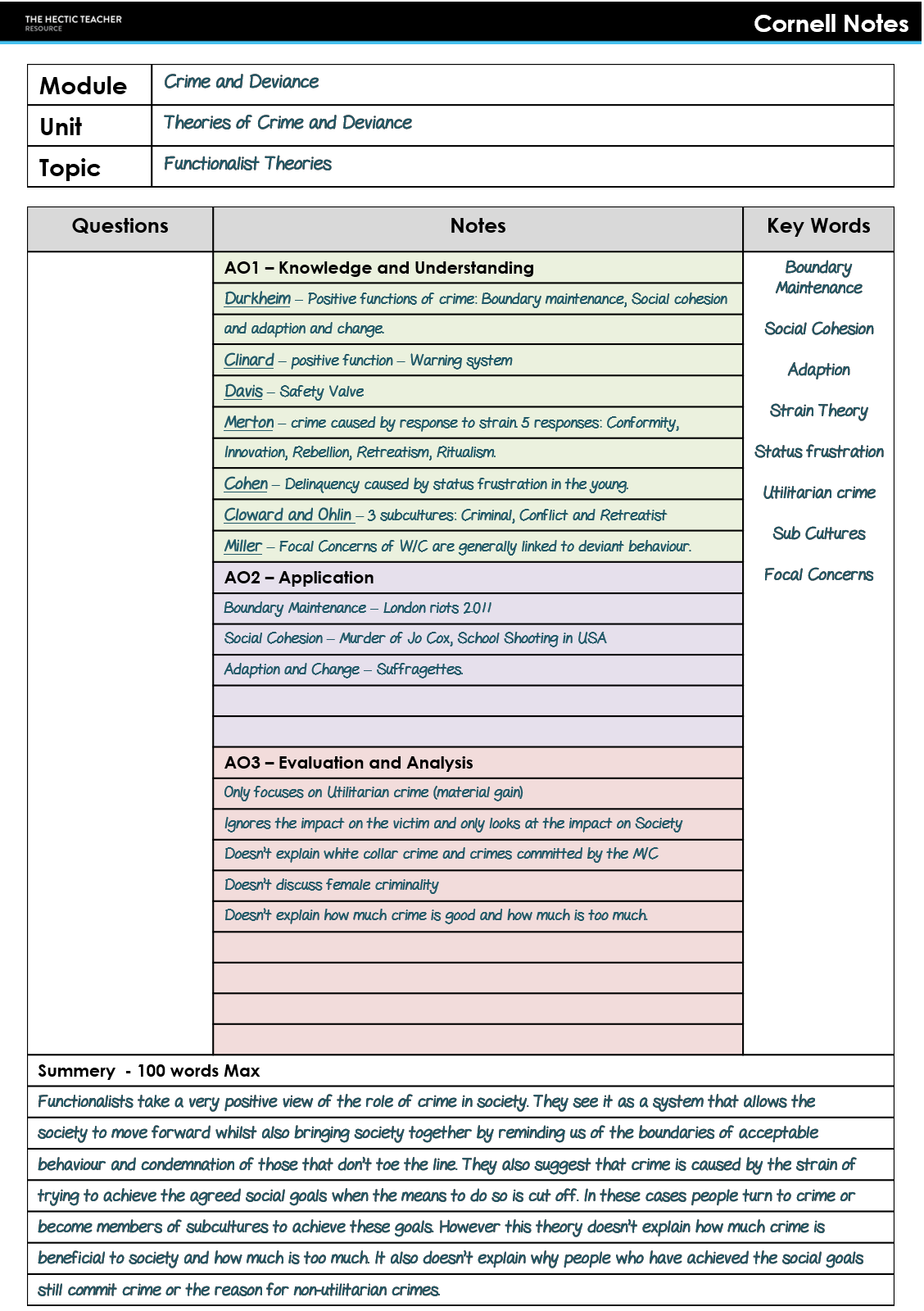Worked Example

www. hecticteachersite.wordpress.com 13 @hecticteacher

Attending your lesson

This may seem obvious but attendance to lessons greatly increases your chances of getting a good grade. Going to the lessons prepared having done the pre-reading will not only make them less stressful but also means that you are able to expand on what is being taught, ask insightful and pertinent questions and start to make synoptic links to other areas of the course / your study.

To ensure that all of your lessons are productive you do need to make sure you:

• Take the correct equipment.

• Basic Equipment for all lessons regardless of subject should include:

• Folder neatly organised and tidy in a folder or file.

• Pens, Pencils, highlighters etc.

• Your textbook

• Lined paper or notebook to write on

• Bring any homework that you have been set by your teacher.

Stage 3 - Consolidation of Notes

In this stage you are bringing together your pre-reading and your class notes. This allows you to see if you have any gaps in your knowledge and if there are areas that you are weaker on.

Long Form Notes
It is a good idea to create long form notes which bring together the notes you have taken in class, your pre-reading and any discussion that has occurred. Long form notes are written in paragraphs with sub headings to help organise them. It is also an idea to colour code your long form notes to correspond with assessment adjectives. Keeping these notes in a notebook or in a
folder organised by unit or topic.

ALevel Sociology
Unit3CrimeandDeviance
Functionalist Theory of Crime

Theory 1:Durkheim’s Positive Functions of Crime

Crime is necessary and inevitable insociety.
It performs vital functions for the maintenance and evolution of society. There are three main functions that crime and devianceperforms:
1) Boundary Maintenance– reminds people what
is acceptable behaviourwithin society. For example the publicising of punishmentsto show society the consequences of deviant or criminal behaviour.
2)Social Cohesion– crime can bring society together against the perpetrator of the devianceor
crime. For example the vigils after the Manchester
Bombings and Jo Cox’s Murder
3) Adaption and change – deviancecan inform society that certain normsneedto change inorder for society to continueand evolve.For example the changes to attitudes towards homosexuality.

However, Durkheim doesn’t tell us how much deviance is necessary and how muchis too much.He also fails to look at the impact of crime onthe victims taking a completely macro view of the phenomena.

Whilstyouaremaking thesenotes you shouldhave yourtextbook,classnotesand pre-reading notes with you. Ideally thisstage should take place as soon as possible after the lesson whilst everything is freshin your mind. Itisalso helpful to have postitnotes to hand to write questions, orconcepts that youareunsureabout on sothatitremindsyou to look itup oraskyourteacher about.

Stage 4 – Trigger Sheets

A trigger sheet is an A4 summary of the topic you have just learnt about. This may not be able to be done after a single lesson but should be completed after each learning phase. The idea is that you are able to summarise the content into an A4 sheet that will act as a reminder and jog your memory. There are a number of different formats that these can take depending on your preference and subject, including:

• Summary Sheets (if available in your subject area)
• Spider webs
• MindMap
• Cornell Sheets

Each of these activities are explained on the following pages and have QR codes to link to any worksheets/resources.

Triger sheets are also a great activity when revising a topic. You can try and fill in as much of the sheet as you can after reading through your notes to see what you have remembered and what you need to go back over. This will be discussed later in the booklet.

Summary Sheets

Summary sheets may just look like boxes on paper but they are graphical way to organise notes so that hey are more logical. They also help to identify the key information that you need to know (minimum requirement). A Summary sheet breaks down the content of the course into manageable chunks whilst also identifying key terminology and covering all assessment objectives.

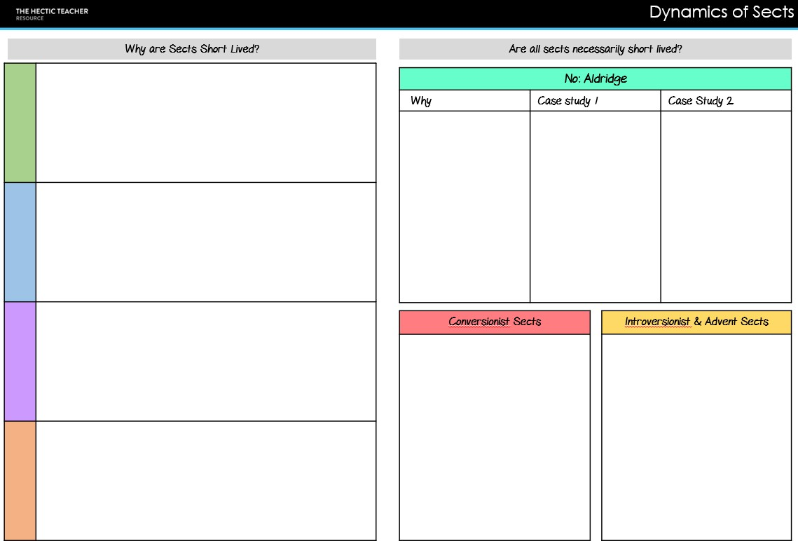
www. hecticteachersite.wordpress.com 18 @hecticteacher

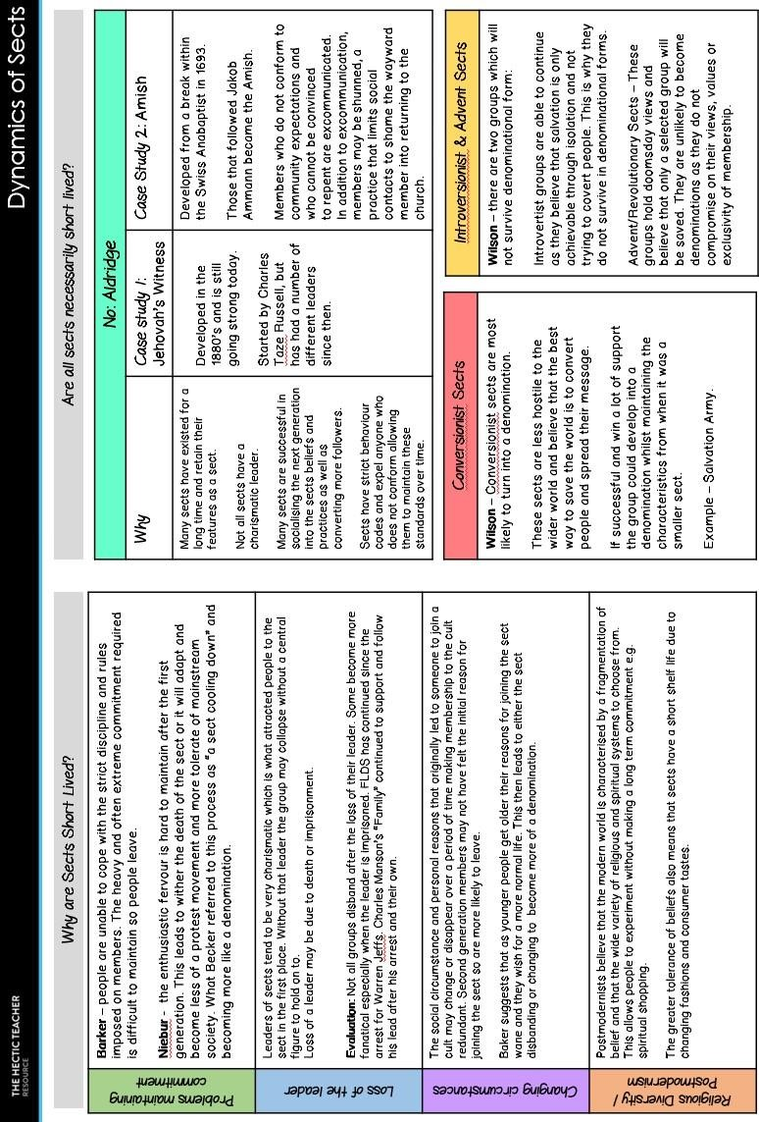www. hecticteachersite.wordpress.com 18 @hecticteacher

A spider web is similar to a MindMap but much more structured and links directly to the assessment objectives. They will not be appropriate for every topic that you study but any topic that has factors, different reasons or ideas this will work. They change slightly depending on the topic, for example some spider webs might have 5 sections where as others might have up to 9, however they all tend to have 3 or 4 levels.

3 Levels
• Level 1 = Identification
• Level 2 = Explanation
• Level 3 = Evaluation
4 Levels
• Level 1 = Identification
• Level 2 = Explanation
• Level 3 = Application
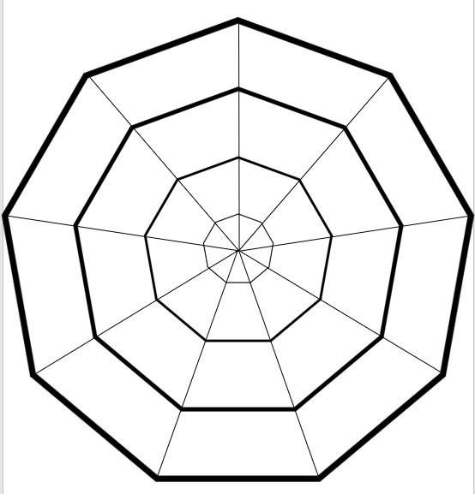• Level 4 = Evaluation

www. hecticteachersite.wordpress.com 20 @hecticteacher

• Level 1 = Identification

• Level 2 = Explanation

• Level 3 = Evaluation (Non Sociological Theories) / Application

f
o e n c o n
Social Constructi
via
(Social construction of Crime and Deviance)

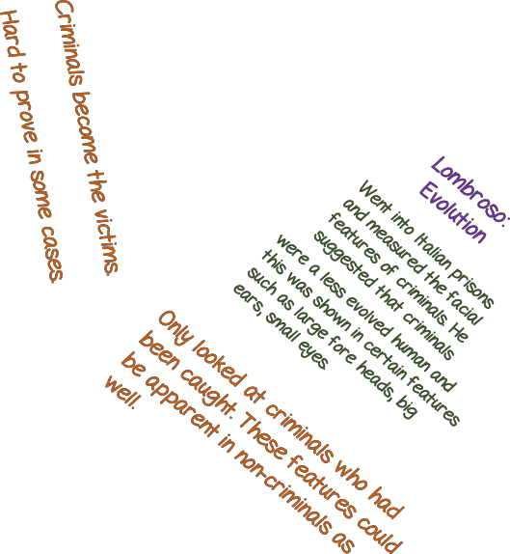Genetics

The Warrior Gene(MAOA)
e D d
n a
e

m i r
C
is present inall humans but insomethe gene gets
mutated which has been linked
to more aggressive behaviour, risk taking and impulsiveness which can all be linked to criminal behaviour.

We don’t knowenough about how this geneworks yet to conclusively link to criminalbehaviour.

Excuse for criminalbehaviour.

A mind map is a graphical way to organise your notes and identify relationships between different ideas and concepts. They are not meant to be neat and can look quite chaotic to an outsider but the important thing is that you know how they work.

Mind Maps start with a central idea and then branch out with other sub concepts and ideas. Branches can be linked to assessment objectives, paragraph structures or any other system you wish to use. The key thing to remember is that you are writing in bullet points NOT paragraphs.

There are lots on online programs that you can use to create your Mind Map but it might be more beneficial to create by hand.

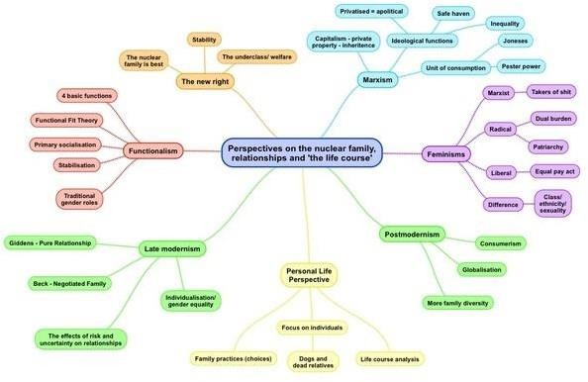

Cornell notes sheets as a trigger sheet is a good way of summarising your topic notes as you are limited in space but are still able to write in paragraphs. If that is your preferred method of writing. The Cornell Trigger sheets are slightly different to the note taking ones as they do not ask you to summarise at the end.

Which exam paper

Specific part of
the specification

Title of the notes you are making

Areas that you are unsure on that you need clarification on
Knowledge - these are the facts that you need to know

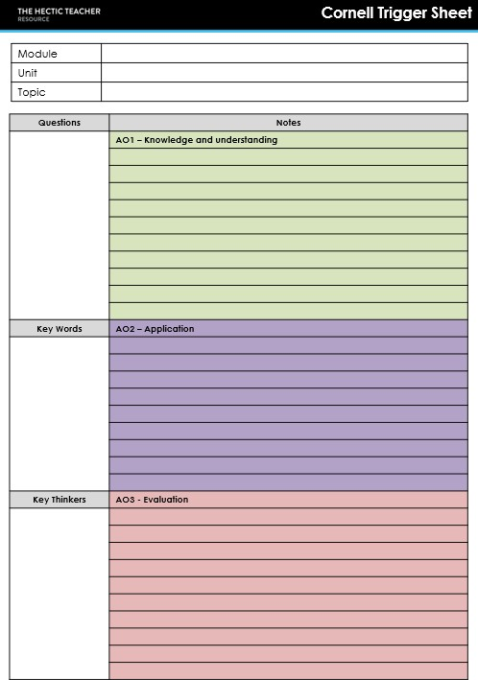Subject specific terminology associated with this topic

Application - examples to illustrate the knowledge.

The specific people that are associated with this topic.

Evaluation – Criticisms and supporting evidence.

Worked Example

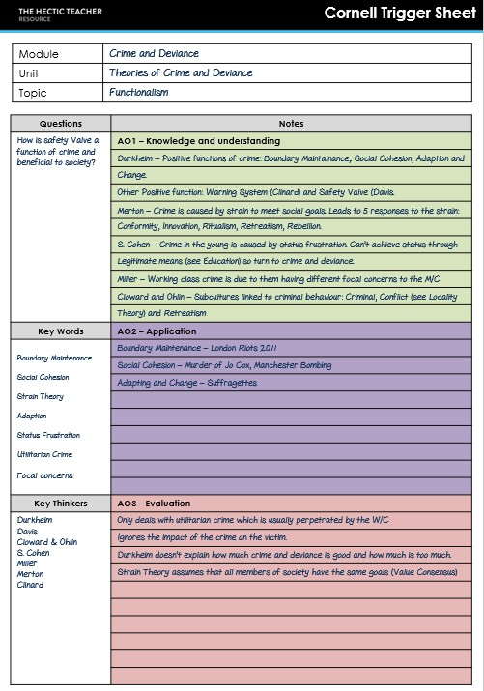

www. hecticteachersite.wordpress.com 23 @hecticteacher
www. hecticteachersite.wordpress.com 24 @hecticteacher

Stage 5 – Self Test / Quizzing

This stage is important as it helps you to find out what you have retained, but it doesn’t have to be boring and can easily involve other people. However, the idea is generally the same, test yourself on the key knowledge of the topic to see what you remember. As a rule of thumb I suggest a pass mark of 75% to move on to the next stage. If you are not getting 75% of the question correct you should go back and review the topic and see where your gaps are.

Ideas for self testing:

• Create / use short answer questions from the exams.

• Online quiz systems such as Memrise and Quizlet. Both of these platforms have a number of ready to go quizzes on most A Level subjects and courses.

• Study Group Quizzing – get together with other students and test each other. If you are all on the same course you can make up the question for each other which would also help you to remember the content and revise.

• Create your own crosswords as part of your review of the topic and then go back to it late to see if you can solve it. There are lots of online programs to do this. But remember that you should wait at least 24 hours between creation and trying to solve.

Memrise Quizlet CrosswordMaker

www. hecticteachersite.wordpress.com 25 @hecticteacher

Stage 6 – Application to Examinations

You should only start on this stage once you are confident and clear on the content of the topic you are studying.

It is important from the start that you are aware of how you will be examined at the end of
your course but this doesn’t mean that you should be doing timed practice straight away. It
is much better for you to be planning longer answers such as essays until you are confident in the style and structure of the answer, as different subjects will have slightly different ways that they want you to write.

When thinking about planning your answers this doesn’t mean writing out your essay in different boxes, it is bullet points of ideas you want to include and showing that you have understood the question that has been asked.

Once you have done this, writing just the introduction and the first paragraph will show if you understood the question and the structure of that essay.

The plans that follow may or may not be applicable to your course so check with your teacher before using.
www. hecticteachersite.wordpress.com 26 @hecticteacher

Relative Importance Questions

One type of question the you could be asked is a relative importance question. These are questions where you have to decide which of a number of factors, ideas, reasons etc is the most important in relation to the question.

For example:

• Assess sociological explanations for the rise in divorce in the last 50 years.

• To what extent was the rapid westward expansion of the United States in the years
1865 to 1890 due to the influence of ideas of ‘Manifest Destiny’?

• Analyse, evaluate and compare the arguments in the above passage for and against the primary and caucus system used to select each party’s presidential nominee.

• Examine differing views about the use of conscience as a guide to moral decision making.

• Assess the relative importance of the roles of water and wind in shaping desert landscapes.

Question breakdown
Introduction planning

The
Question

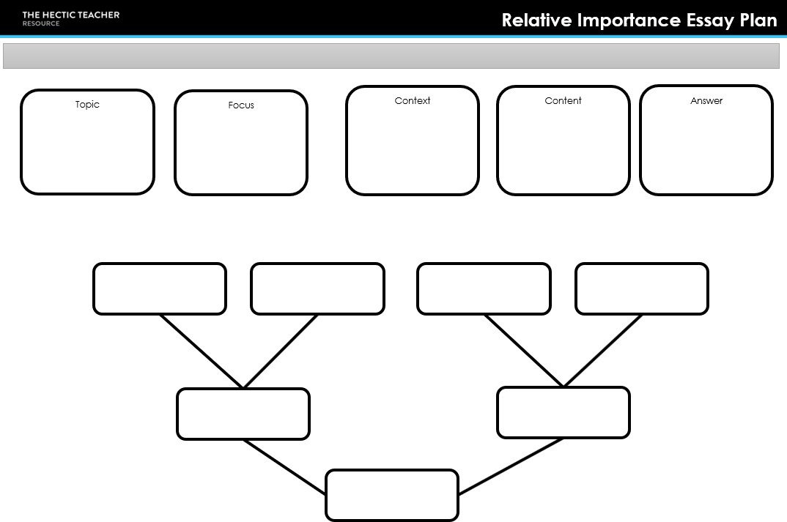The four points you are assessing

The two points that are the most important from the four
The most important
from the four
Annotate the reasons you have chosen one factor over another.

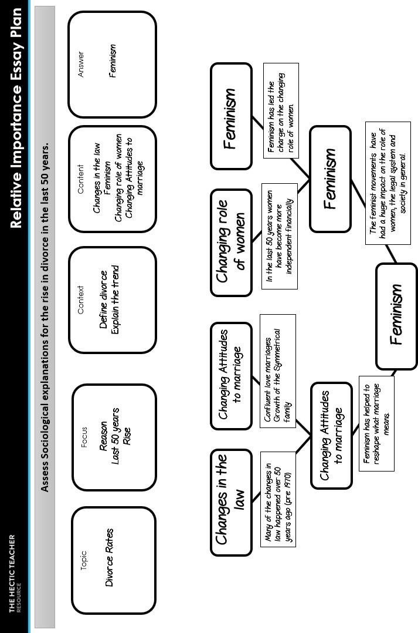Worked Example

www. hecticteachersite.wordpress.com 27 @hecticteacher
www. hecticteachersite.wordpress.com 28 @hecticteacher

Evaluation Questions

Another type of question that you might get is an evaluation question which as a yes or no type of answer. This could be the extent to which you agree with a particular view or how useful a particular theory / idea is. Some times you will have an item to help you but sometimes you might not.

For example:
• Evaluate the usefulness of Marxist approaches to understanding the causes of crime.

• ‘Despite their weaknesses select committees play an increasingly central role in
British Politics.’ Analyse and evaluate this statement.

• ‘A deontological system of ethical decision-making is unsatisfactory.‘ Evaluate this
claim.

• ‘The key to all the triumphs and disasters of the Liberal Party in the years 1906 to
1924 was David Lloyd George.’ Assess the validity of this view.

• Assess the extent to which there are inter-relationships between processes in the water cycle and factors driving change in the carbon cycle.

The two question breakdown sheets that follow are one way of planning your answer in such as way that you are not writing but the essay in boxes, but really thinking about the content of your answer. There is one for questions which have an item attached and one for questions which do not.
www. hecticteachersite.wordpress.com 29 @hecticteacher

With Item

Break down the question to fully understand what is being asked.
The item for highlighting

The question

Key words from the question to help you stay focused.

What are you going to include in your introduction
Information from your own knowledge, not the item

Without Item

Highlighting
Key

Why you have highlighted that section – Do not quote

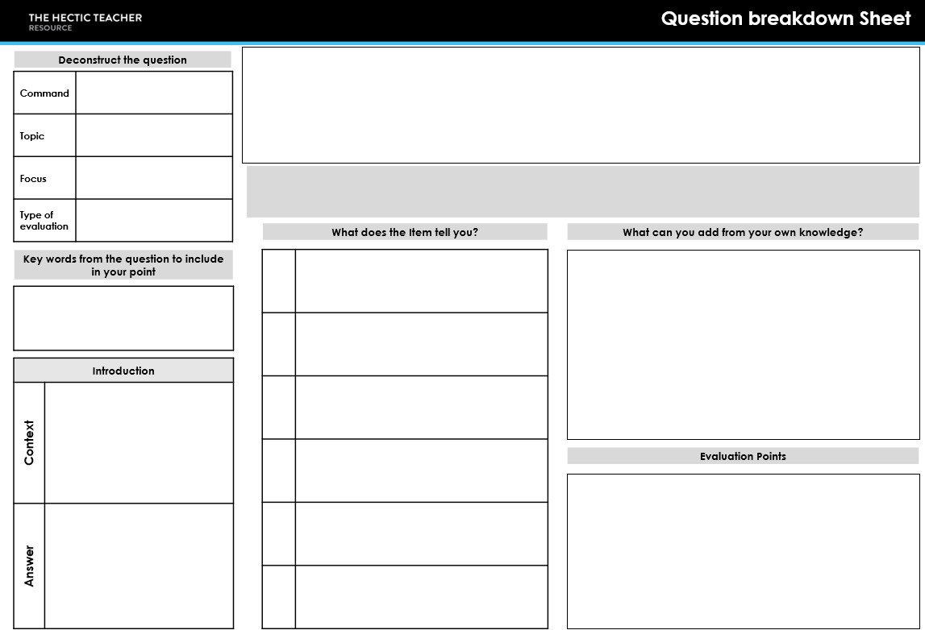Information that can be used to evaluate

Break down the question to fully understand what is being asked.
The question

Key words from the question to help you stay focused.

What are you going to include in your introduction

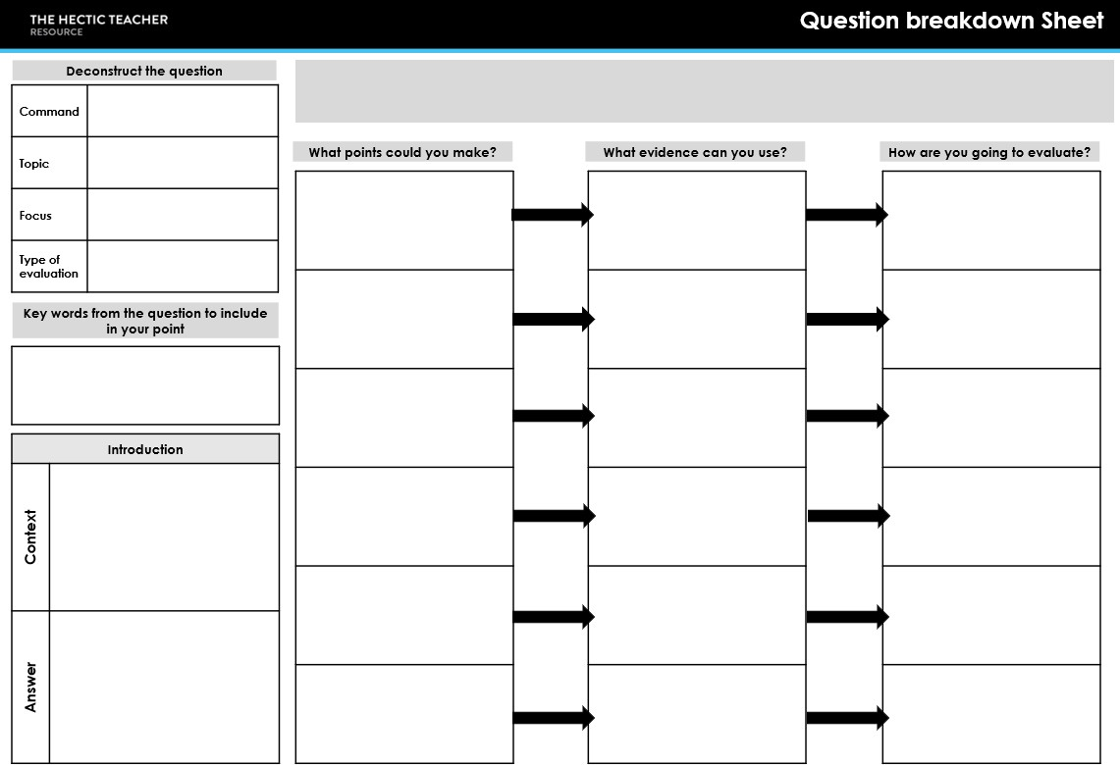AO1 - All the points you could make, highlight the ones you are going to use.

AO2 – Evidence and illustrative points
AO3 - Evaluation that links to the point being made.

Worked Example

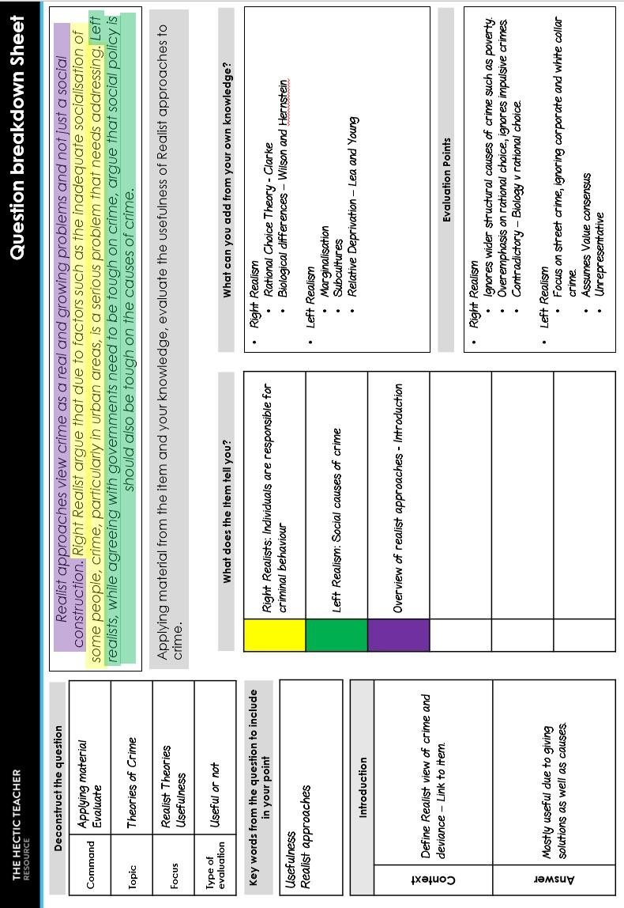

www. hecticteachersite.wordpress.com 30 @hecticteacher

Stage 7 – Timed Practice and Self Marking
You should not move on to this stage until you are confident in your planning and structure. Timed practice is important as you need to be able to answer the exam style questions
under timed conditions. It is also important that you self assess these timed questions as this
will help you to remember what it is the examiners are looking for.

When completing timed questions it is a good idea to have someone else time you or to work in a study group so that you are focused, it is all too easy to make excuses to give yourself more time.

If you do not finish the question in the time allowed in the exam you should complete it in a different colour. This will show what you can do in the time allowed and as you practice more the amount of the second colour should start to diminish until it finally disappears.

It is okay to repeat the questions you do, that way you are able to see how much progress you have made in the time between the attempts, however you should wait at least a couple of weeks between the attempts, this will prevent memorisation of the essay (which is not the aim) and also allows for you to get feedback from your teacher (who may take a little time to mark or check your independent work).

You should however practice a range of questions and not just the ones you are confident in. You should really focus on the style of question that you are least confident in with other styles included as well, so you don’t get bored.

Remember to check with your teacher that the self assessment forms are appropriate for your subject. You will need access to generic mark schemes to determine a band, These are usually available from the exam board website or your teacher.

Tick if you have done this. Each column isa different paragraph.

Areas to focus on in the future in terms of structure, literacy and content. Max 3 points.

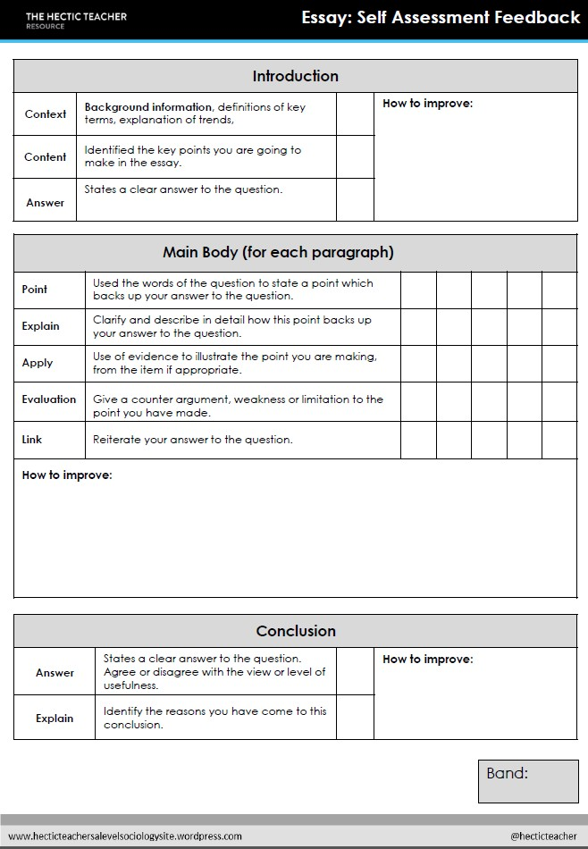Which band of the mark scheme would you place your answer. Not a rawmark.

Worked Example

Use the wording of thequestion
✓
inthe introduction.
✓

Makesure that the answer is
✗ clear and direct.

✓✓ ✓
✓✓ ✓
✗ ✓ ✗
✗ ✗✓
✓ ✗ ✓

• Rememberto evaluate every point.

• Use the item explicitly at least 2 times inthe essay.

✗
Rememberto write a
✗ conclusion!

3

Stage 8 – Focused Review and Revision.

Revision is not something that you should wait to start, but a continuous part of your studies. You should be returning to previous topics regularly to keep it fresh in your mind. By doing this it will prevent stress and anxiety as you head towards exams because you will be able to better identify areas of focus both in content and exam technique.

Ideally focused review and revision should start after about 2 weeks after completing the topic in class and the study system. This will enable you to see how much you have retained and if there are any gaps in your knowledge or understanding. It is also really important that you ask for help if you are unsure or confused on anything. DO NOT leave this till the last minute.

Focused review is process which has 3 stages:

1) Quick Review
• Read over your notes and/or textbook to give you a reminder of the topic.
You do not need to take notes or highlight anything at this point, it is just a chance to refresh your memory on the topic. It should take no more than 5 minutes.

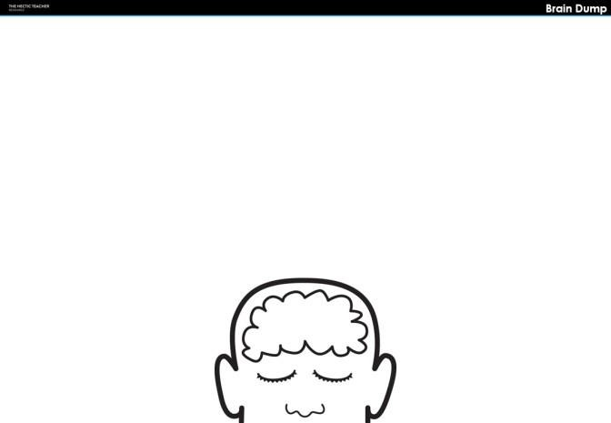2) Brain Dump
• A brain dump is a timed activity where you write down everything you can
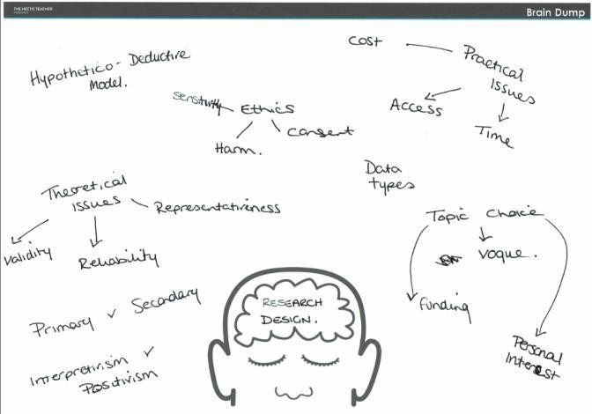remember about the topic you are revising. It is not meant to be neat or organised it is simply an indication of that you remember. It should take you no more than 8 minutes to complete this task.

Alternatively you could use the spiderweb sheets that were discussed earlier if you prefer something with a little structure.

3) Focused Review
• At this stage you are going to go back over your notes and using the focused review sheets and key word quadrants. This will identify the areas you need to look back over and identify areas you need to get help with. To do this you use you notes, textbooks and other resources a long side your brain dump to note down the elements that you need to relook at and questions you have your teacher. This stage should take around 15 minutes.

Which topic
you are looking
at. To organise
your notes.

Bullet points of information that isn’t on your brain dump.
Key thinkers that you missed.

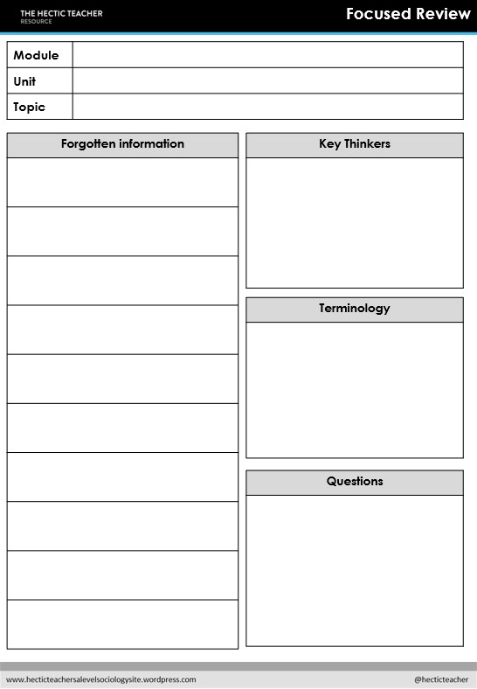Terminology that you missed.

Things you want to check with your teacher or study group.

Once you have completed the focused review, and there are areas you need to revise in more depth you should revise those areas using the strategies mentioned earlier as part of the note taking and then go back to Stage 4 of the spaced system to continue the revision and apply to exam techniques.

The spaced study system is a circular system meaning you keep returning to the topic and the various stages as you go though your studies, the end comes with your final exam at the end of your course.

The key points to remember are:

• PLAN your time effectively, use your study periods well to either study or complete homework.

• ASK if you need help, when you need it, don’t wait until just before an
assessment or exam.

• RETURN to previous topics regularly to keep knowledge and skills fresh.

• TAKE CONTROL, These are your studies and although your teachers and school staff are there to help and support you, they cannot take the exam for you, so at the end of the day it is up to you to do what is necessary to get the best grade you possible can.

